Trace FC Tutorial: Running Experiment

(Note that this will eventually be replaced with a jupyter notebook once I figure out how to nicely embed figures on windows).

This tutorial will cover the steps in **bold** here:

1. Handle animals
2. Set up hardware and arenas
3. **Set up software**
4. **Run experiment**
5. Organize/backup data

Set up software

**USV RECORDING**

First, open up AVISoft recorder for recording ultrasonic vocalizations (USVs) and go to the configuration dialog box:

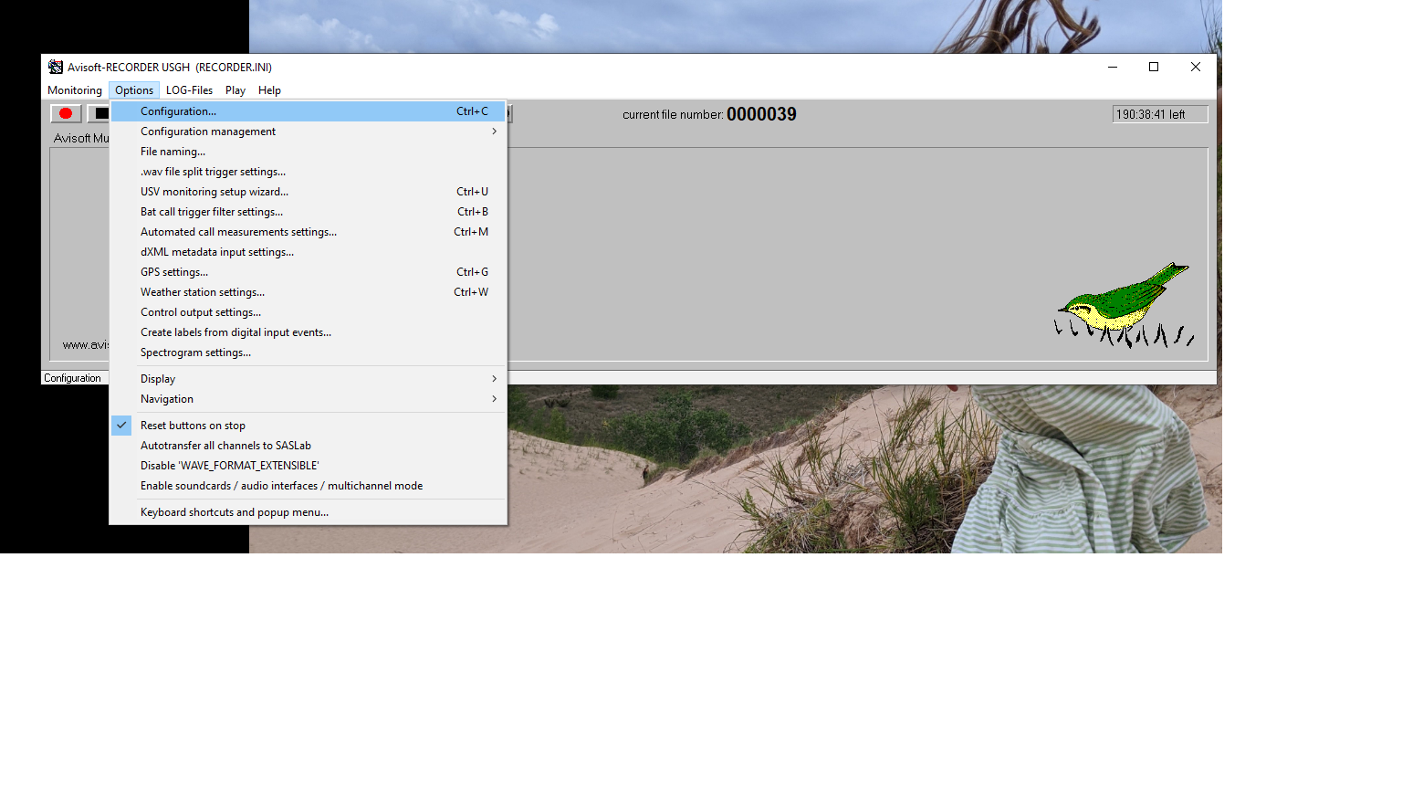

Next, name each channel to as below to match the channel each microphone is connected to by filling in the text in the red box below.

Then, make sure you are saving everything to the appropriately named folder for your experiment (typically Ratxxx in the Documents\Recordings folder) – see green box below.

Last, hit “Config File -> Save As” and save to the same folder as the base directory – see yellow below.

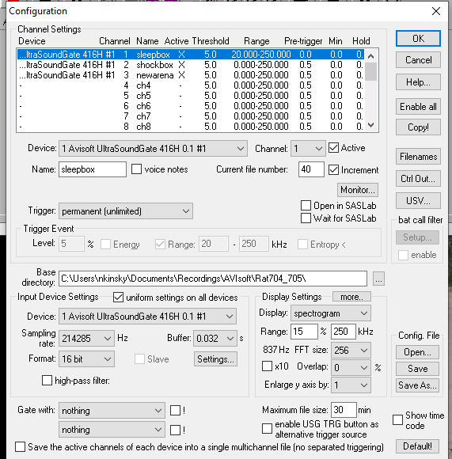

Third, uncheck all but the active microphone by toggling the “Active” box for each channel – see red box below.

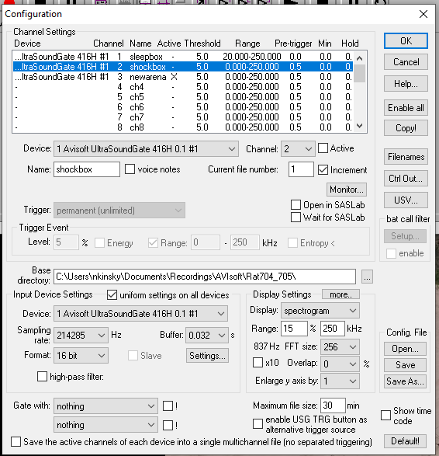

Finally, make sure that the microphone is working by hitting record and then going over to the microphone and snapping your fingers. (Note that it is a bit buggy and you might have to close an error box and hit record again to get things working). You should see a nice response across all frequencies. If it doesn’t look that strong, double check to make sure you have the correct microphone selected and that each microphone is connected to the correct port.

You are all set to record USVs!

**Behavioral Recording**

First, open up Motive (type “motive” in start menu) AND Camera (type “Camera” in start menu). You should see something pop up like this below. Make sure that you have selected the correct camera for the recording by clicking “Enable” in red box below. The other cameras should show up as black.

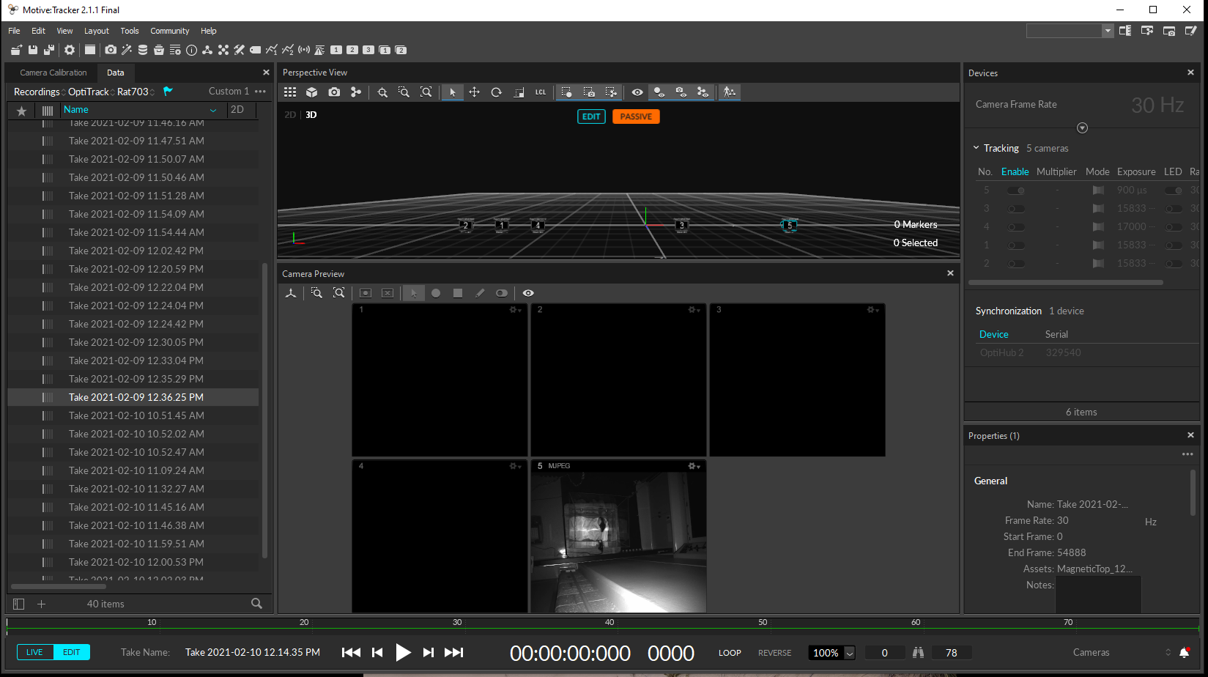

If this is your first recording for a given animal, make sure to designate where the files will go by selecting “Add session folder” from the file menu and creating a folder with the rat’s name (typically in the “Documents” folder):

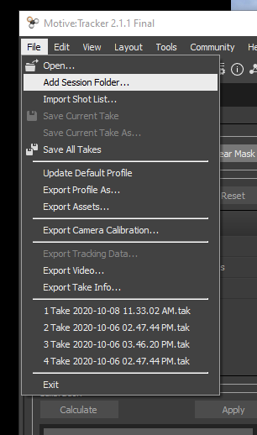

Double check recordings are working by hitting the red button at the bottom to start recording and making sure something shows up in the designated folder.

Finally, set up the webcam, which serves as a backup in case Motive crashes. All you need to do is CAREFULLY get up on the step ladder and adjust where the camera points so that it shows up looking at the correct arena on the application.

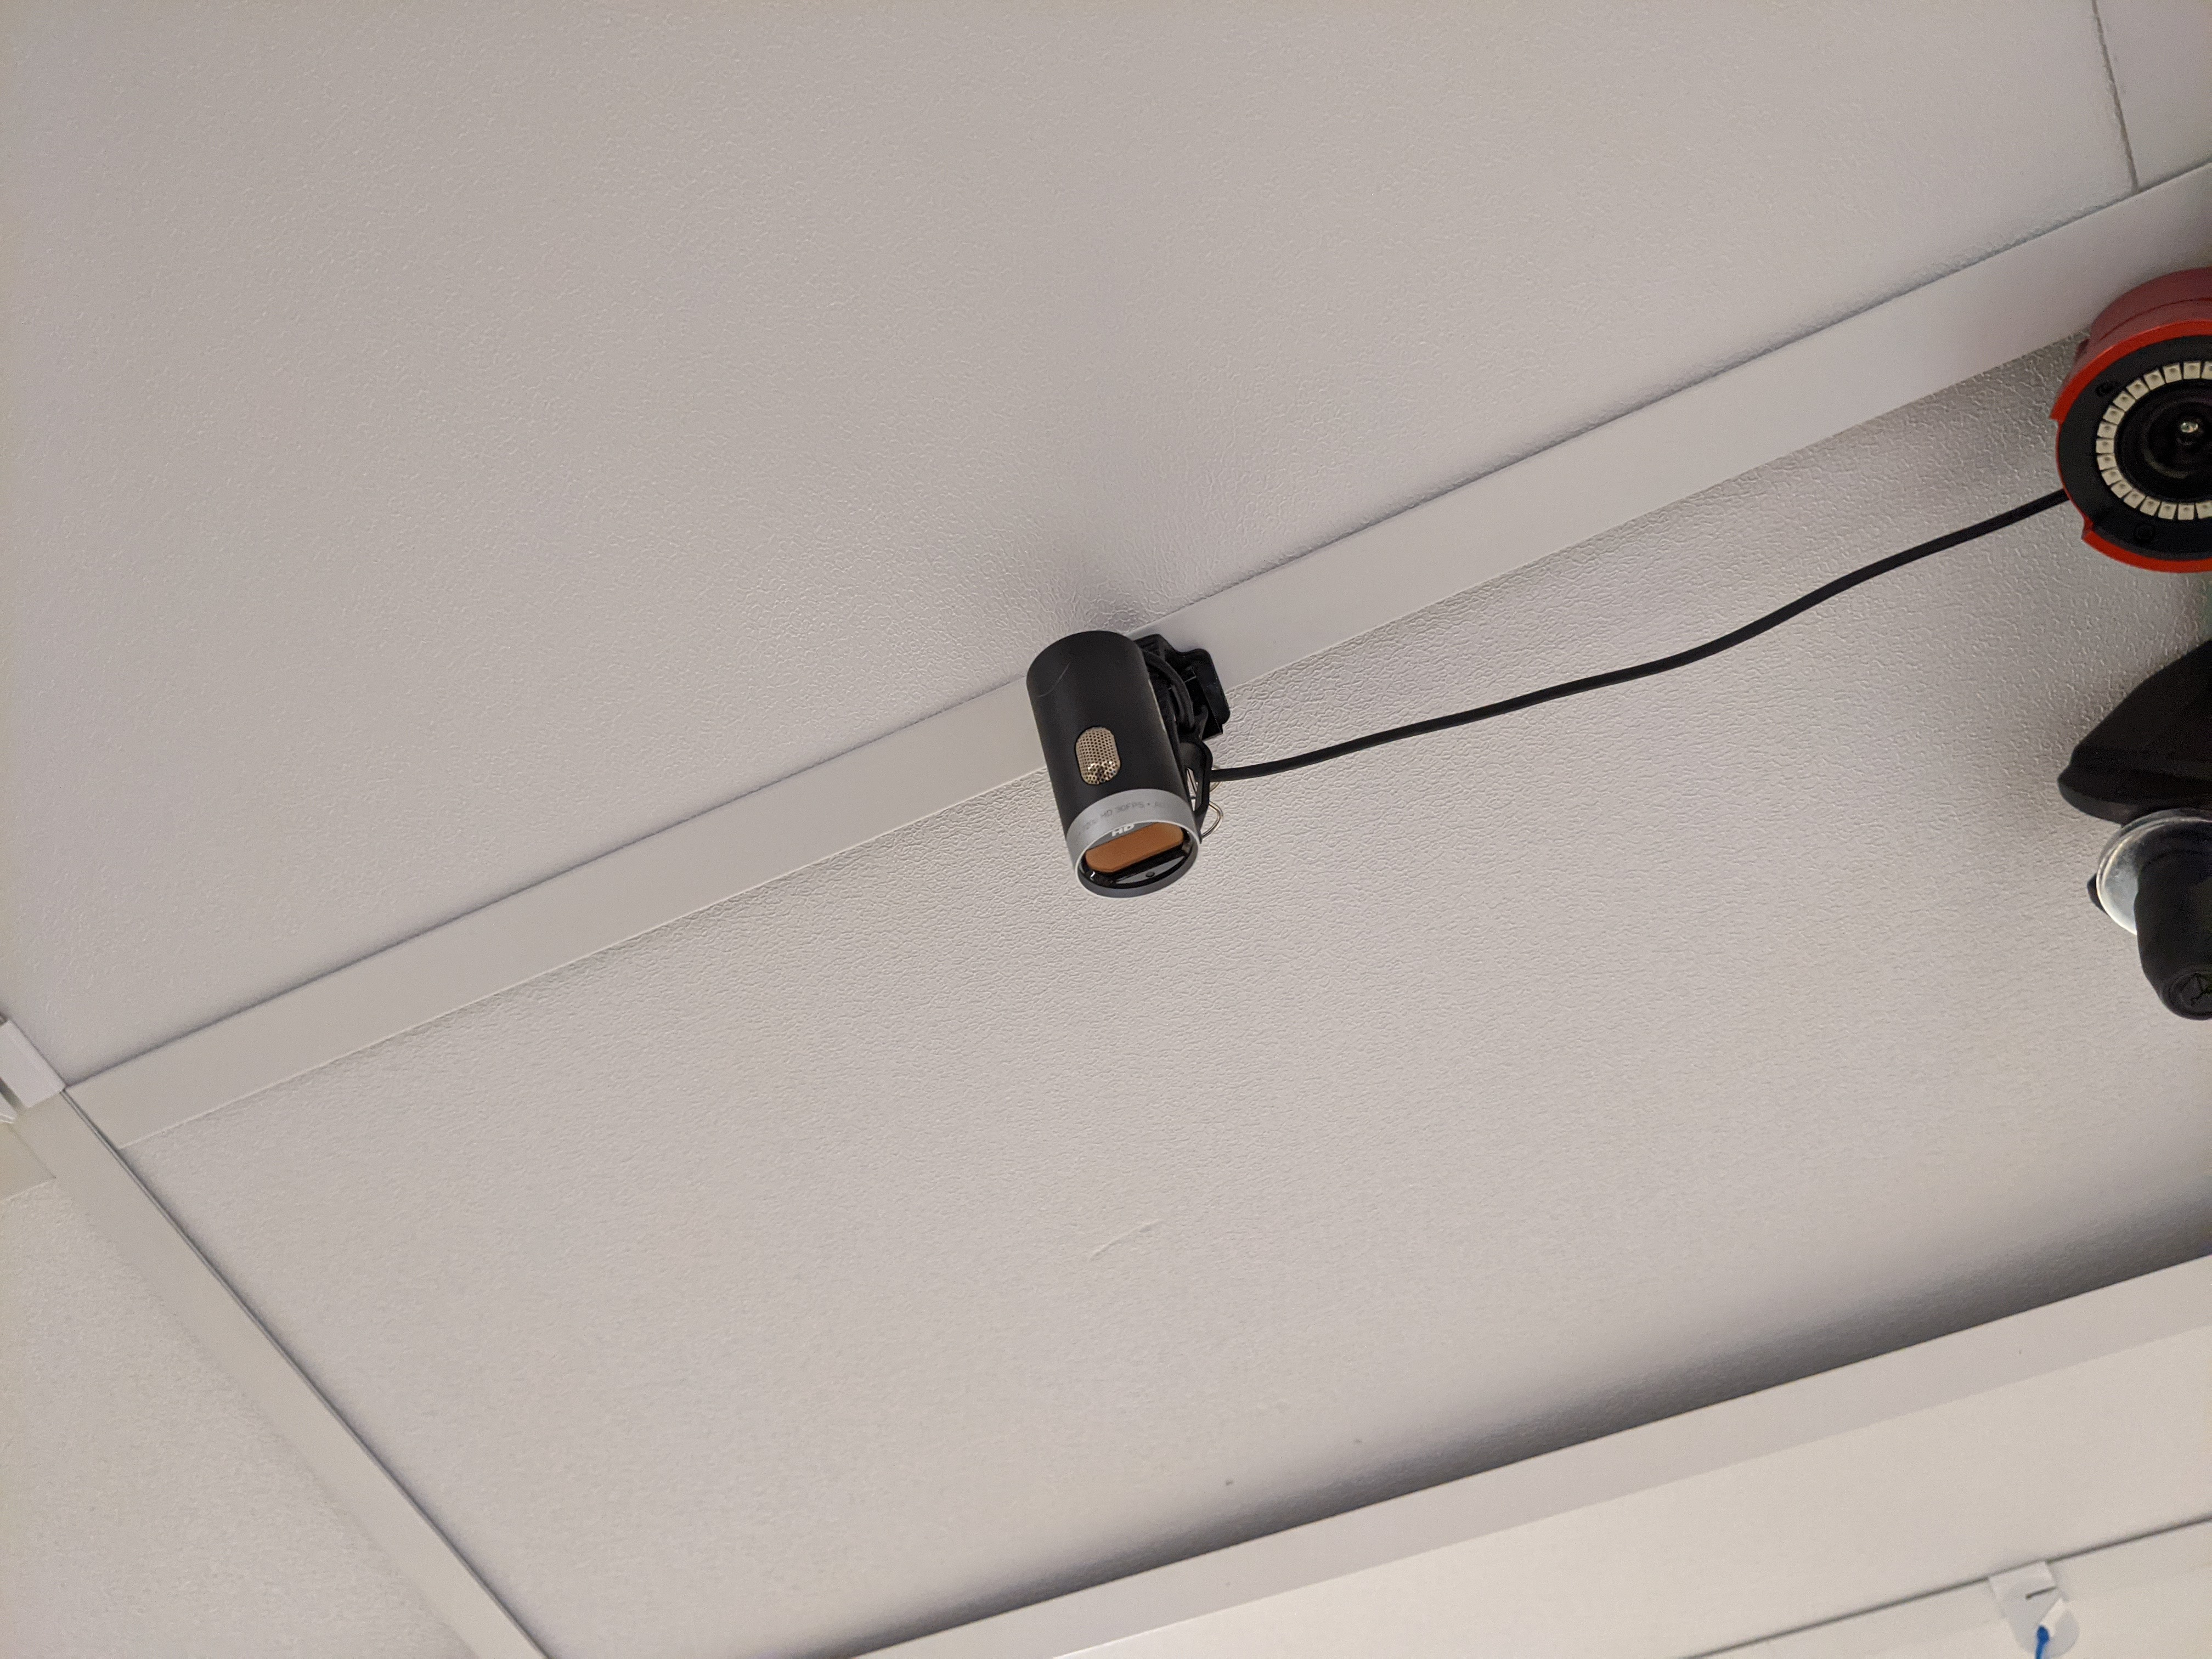

Again, test to make sure it is working by clicking RECORD and ensuring you see a new file show up in the location below.

IMPORTANT NOTE: This app will STOP RECORDING if you minimize it, so be sure to not do that!

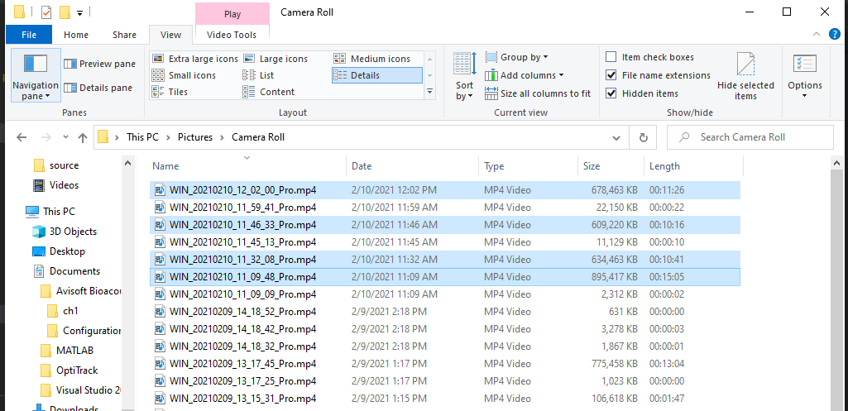

**Set up python class to run experiment**

Now you are onto the fun stuff!